TEP / ISB

Technology Entrepreneurship Programme (TEP):
- An initiative of Indian School of Business (ISB) called Technology Entrepreneurship
Programme(TEP) has | come into existence with | the initiatives | of | AP
Society for Knowledge | Networks(APSFKNW), | Department |  | of
Information Technology & Communications, Government of Andhra Pradesh in the year 2014 with an objective of generating Technology Entrepreneurs by duly incubating with VJTBI & ISB, Hyderabad. Later after separation of the A.P State, this programme is being organized by Telangana Academy for Skill and Knowledge (TASK) ,promoted by Government of Telangana.
- This programme (TEP) is designed, organized and sponsored by Telangana Academy for Skill and Knowledge (TASK) which is promoted by Government of Telangana to encourage the culture of Entrepreneurship among students community having technical qualification. All the selected students are required to pay an amount of Rs 8,000/- per year towards tuitions fee.
- 39 students have selected during the year (2014-2016) and have undergone training with ISB through off line & on line modes and obtained their certificates on completion of 2 years’ time.
- 50 students have been selected for TEP / ISB during the year (2015-2017) and have undergone training with ISB, Hyderabad.
- 19 students have been selected for TEP / ISB during the year (2016-2018) and have undergone training with ISB, Hyderabad.
- 46 students have been selected for TEP / ISB during the year (2017-2019) and obtained their certificates on completion of 2 years’ time from ISB, Hyderabad.
- 14 students have been selected for TEP / ISB during the year (2019-2020) and are undergoing training with ISB, Hyderabad. The duration of this certificate programme was squeezed to one year from two years from this academic year onwards. The programme is meant for II year B.Tech, 2nd Semester students of all branches.14 students have obtained their certificates on completion of 1 year time from ISB, Hyderabad.
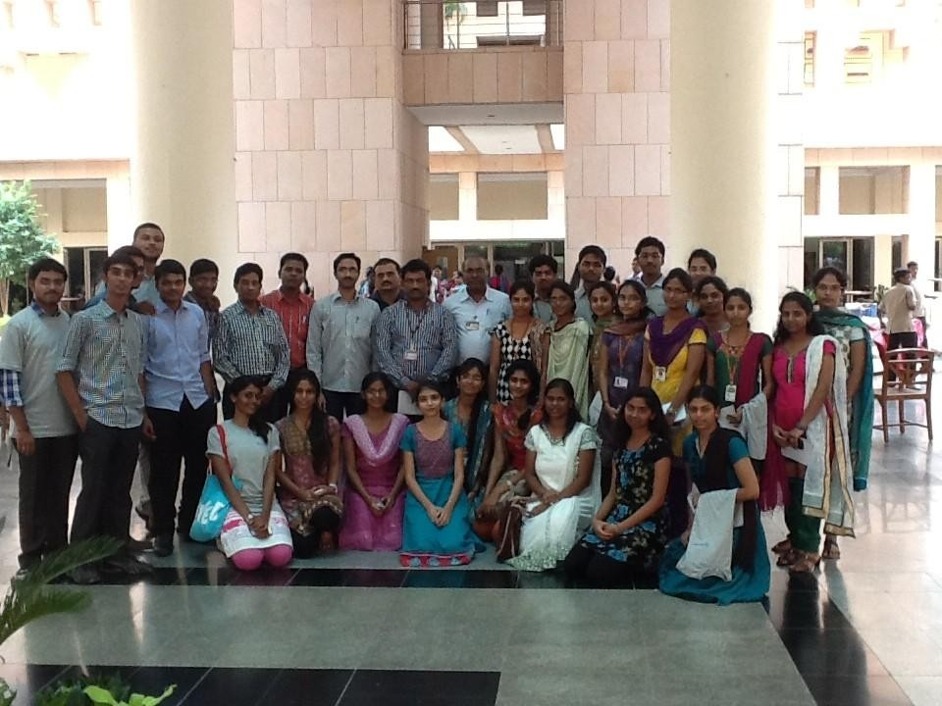
First Batch (2014-2016) Students of TEP at ISB, Hyderabad.

